Dates to remember

Half term – Monday 30th may – Friday 3rd June (closed to funded/term time only children)

Jubilee Bank Holiday – Thursday 2nd & Friday 3rd June (closed to all children)

This Month’s Topics

This month we will be learning about how to keep ourselves safe and healthy. There will be a range of activities going on throughout the month promoting healthy eating and hygiene.

If any parents have any activity ideas or would like to join us to lead an activity please let a member of staff know.

**Covid-19**

Sadly due to the current situation we have had to adapt some of our regular practices.

We continue to steralize and deep clean the setting on a regular basis and will continue to take childrens temperastures on arrival.

If your child is displaying symptoms, a new cough, temperature over 37.8 or a change to taste or smell, please do not bring them to the setting, you will be asked to isolate for 5 days or provide proof of a negative covid test before returning.

As restrictions are easing we would like to invite parens back into the setting, however we ask that you please respect social distancing and not to entre the setting if you have sypmtons of covid-19 unless you have received a negative test result

**FOR FULL DETAILS PLEASE READ OUR LATEST COVID-19 POLICY. ALL PARENTS ACCESSING OUR SERVICES ARE EXPECTED TO ABIDE BY THIS POLICY AT ALL TIMES.**

**UPDATED CONTACT INFOTMATION**

 0208 689 8440

[info@learningcottagepreschool.com](mailto:info@learningcottagepreschool.com)

 07494 476535

 <https://www.facebook.com/The-Learning-Cottage-Nursery-107066395242594>

 <https://www.learningcottagenursery.co.uk/>

Donations for Delvin

Sadly a few weeks ago a child from one of our other setting was diagnosed with cancer. He is currently in hospital fighting this dreadful disease and his family is going through some very difficult times. His parents are taking turn’s to stay with him in hospital and this has obviously brought disruption to their lives.

Your kind donations will go to the family and will help to help them towards expenses and difficulties they are facing every day in order to give Delvin the support he needs

Thank you for your support

Absences

If your child will not be attending nursery for any reason, please inform us by 9.00am.If you are paying lunch fees and do not inform us that your child will not be attending, you will still be charged a fee for that day, as the food will be prepared for them.



As our topic this month is “keeping healthy and safe”.

A fantastic and fun way for children to understand how we can eliminate germs is an activity called glitter germs.



All you need is some glitter to rub on your hands, a bowl of water, and some soap.

The idea of the activity is that the glitter represents the germs and they have to clean if all off so no germs are left. It’s not as easy as it sounds



Friday 8th July will be our yearly trip to Chessington world of adventures

**Polite Notice**

**Please do not park in front of the drive way.**

**The drive belongs to the church next door and they need access at all times.**

**Thank You**

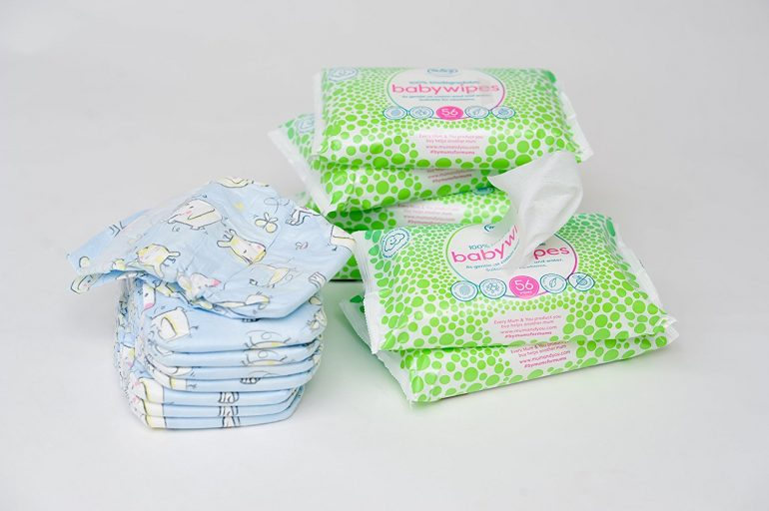

Please ensure you child has a named bag or back pack containing

* Spare clothes
* Slippers
* Water bottle
* Blanket
* Wet wipes
* Nappies
* Sun hat/cream

Please unsure all items are clearly labelled. No plastic bags please

Nursery Essentials