Dates to remember

INSET Day – Friday 2nd September 2022(closed ALL children)

Term starts - Monday 5th September

Half Term – Monday 24th October- Friday 28th October 2022 (closed funded/term time only children)

**WELCOME ALL**

We would like to welcome you all back and hope you had a lovely summer break. Also welcome to all our new comers. We look forward to getting to know you all and working closely with you in the future.

What will be happening this term?

We have lots of exciting things happening this half term. In September our topic is All about me. The children will be sharing all about themselves and their communities with each other. We will be visiting different places of worship such as local churches and temples and asking parents to join us to share their cultures and backgrounds.

In October we will be celebrating Autumn and harvest, we will be taking local walks to look for signs of the changing season and Harvest donations for local food banks.

**UPDATED CONTACT INFOTMATION**

 0208 689 8440

[info@learningcottagepreschool.com](mailto:info@learningcottagepreschool.com)

 07494 476535

 <https://www.facebook.com/The-Learning-Cottage-Nursery-107066395242594>

 <https://www.learningcottagenursery.co.uk/>

Harvest Donations

Throughout October we will be collecting harvest donations for a local food bank. If you wish to donate please let a member of staff know.

Suggested donations

* Canned goods
* Dried good such as pasta/rice
* Jar foods such as sauces/jams
* Cereals
* Bottled drinks such as squash/water

Absences

If your child will not be attending nursery for any reason, please inform us by 9.00am.If you are paying lunch fees and do not inform us that your child will not be attending, you will still be charged a fee for that day, as the food will be prepared for them.



This term challenge is paper plate faces.

Create your face or those of your whole family, to share at nursery.

Use a mirror to look at the features of your face. What colour is your hair? How many eyes do you have?

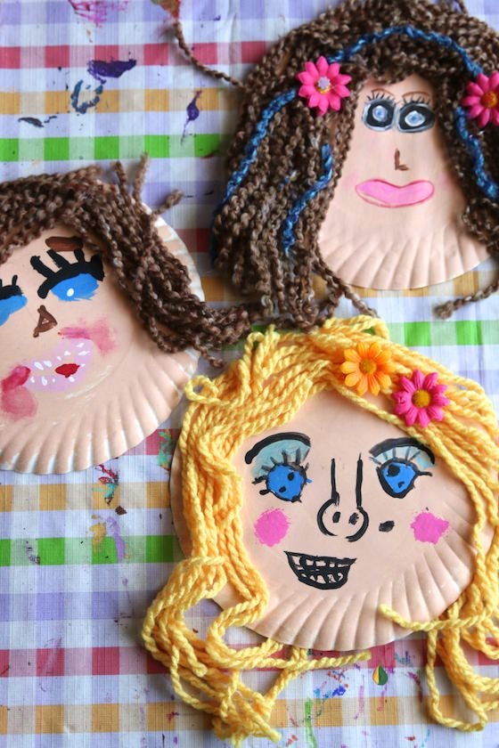

If you need to borrow any resources from the nursery, feel free to ask a member of staff.

And don’t forget to share your creations of Tapestry.

POLICY OF THE TERM

This term, instead of sharing a policy, we would like to share a guide to tapestry with you all, to ensure you are using it to its fullest. Please see the guide attached to this email.

**Polite Notice**

**Please do not park in front of the drive way.**

**The drive belongs to the church next door and they need access at all times.**

**Thank You**

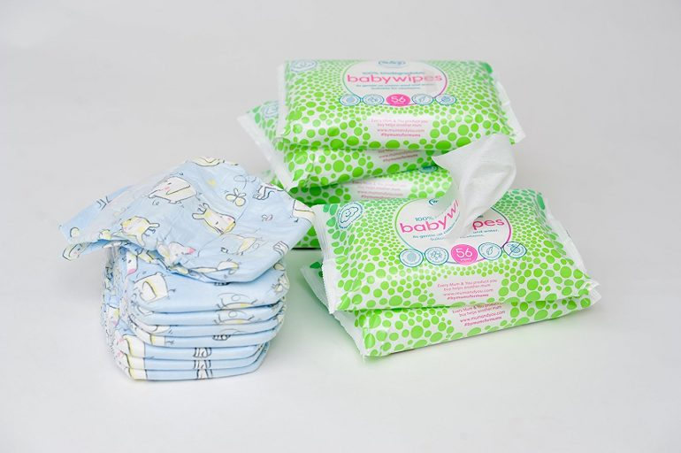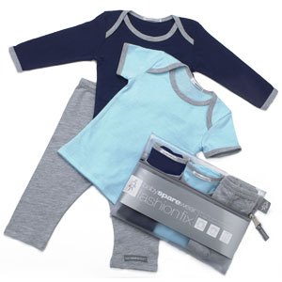

Nursery Essentials

Please ensure you child has a named bag or back pack containing

* Spare clothes
* Slippers
* Water bottle
* Blanket
* Wet wipes
* Nappies
* Sun hat/cream

Please unsure all items are clearly labelled. No plastic bags please