Dates to remember



**February 2024**

Half Term Holiday – Closed to ALL children Monday 12th – Friday 16th February 2024

Children return back to nursery -Monday 19th February 2024

**March 2024**

Parents workshop and parents evening- Friday 15th March 2024 (Closed to ALL children)

Bank Holiday – Friday 29th March 2024  
(Closed to ALL children)

**VALENTINES DAY BALL- Friday 9TH February 2024.**

**On this day the children may wear something Red.**

**If it is not your child’s usual day, they may come in from 10:30 am to 11:30 am.**

**Supporting your child at home:**

**What You Can Do to Help Kids Build Self-Esteem**

1. Help Them Learn to Do New Things. One key strategy to help a child feel capable and proud is to challenge them with age-appropriate learning opportunities. ...
2. Praise Them. ...
3. Model the Right Attitude. ...
4. Empower Kids to Help, Give and Share. ...



**Half Term - Pancake Day Challenge.**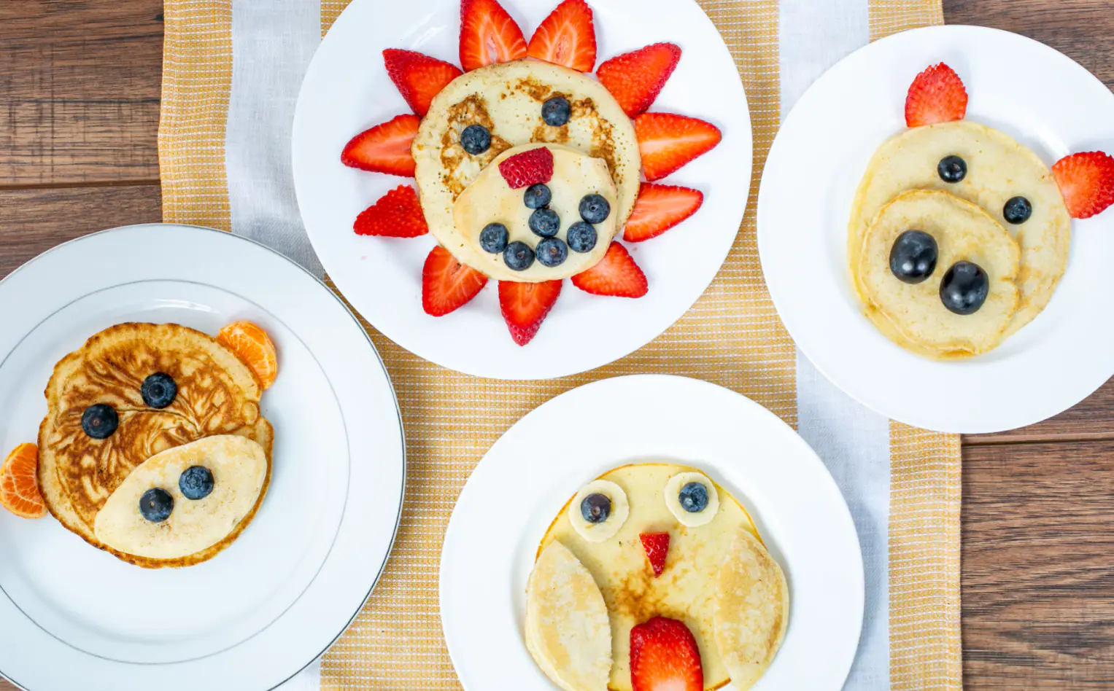

**Design and make a creative sweet or savoury pancake that uses at least two fruits or vegetables in its design.**

* **Creativity and imagination.**
* **Promoting healthy eating.**
* **Incorporating a variety of skills such as pouring, mixing, and chopping**.

**Post your pancakes on the Tapestry App. The winner will be announced and the designed pancake will be posted.**

**Our focus poem -  
Taken from the Poetry Basket**



A little seed for me to sow,  
A little soil for it to grow.  
A little hole, a little pat,  
A little wish, and that is that.  
A little sun, a little shower,  
A little wait, and then a flower.

**A video will be posted in the parent’s WhatsApp group sung by the teachers, please continue to learn this at home.**

**Activities to do at home:**  
What can you plant at home? Inside or outside.  
Can you draw a picture of what it will grow into?

Post a video of your child singing the poem on Tapestry.

+-

**Mother’s/ Carer’s Day Picnic- Friday 8th March 2024**

This year we will be having a picnic at the park.  
Please bring with you a blanket and snacks to eat.

We will also be playing family games and creative activities will be set out.

The address will be sent in the WhatsApp group.

**Thank You for being a superhero without a cape!**

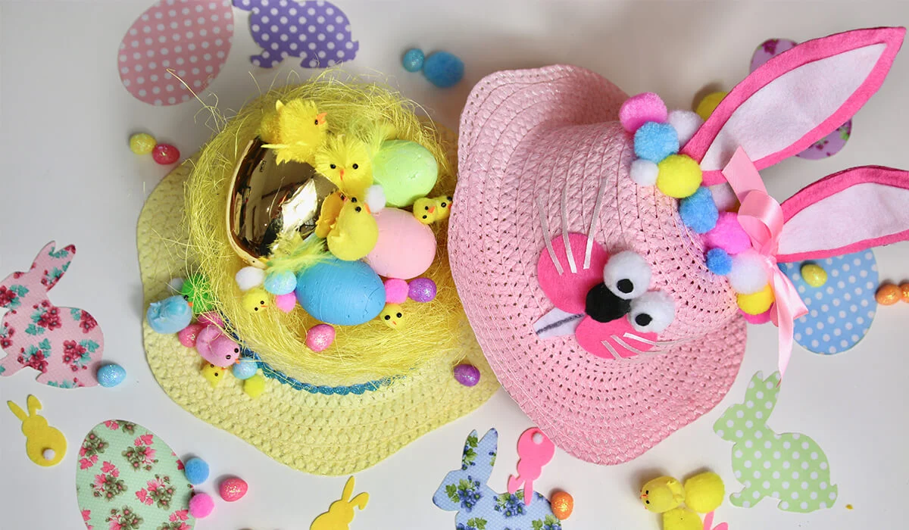





**What is creativity?** Creativity is defined as the tendency to generate or recognize ideas, alternatives, or possibilities that may be useful in solving problems, communicating with others, and entertaining ourselves and others.

**On that note, LET’S GET CREATIVE!**

On the 28th of March 2024, we will be having an Easter Bonnet Parade.

Parents are invited to the setting at 10:30 am, where the children will be showcasing their Easter Bonnets, they made at nursery.

We will be using World Book Day as a way to share our favourite books.

Children may dress up as their favourite character from a storybook and we encourage you to use things you already have at home. Alternatively, you may order from Amazon, eBay or your local Tesco, Sainsbury or Asda will have in stores.

From the 4th March to the 7th March, we are inviting two parents per day to join our story time session, at 10 am for 15 minutes. Please bring in your own children’s storybook. This may also be in your home language.

**Why is reading important for young children's development?**

Reading daily to young children, starting in infancy, can help with language acquisition, communication skills, social skills, and literacy skills.

**What book are you reading this week?**

Are you eligible for 30 hours? Not sure?   
Scan the QR code with your mobile camera  
and will bring you to the website to apply.



Alternatively, copy and paste the link below.

https://www.gov.uk/30-hours-free-childcare

For working parents of children aged 3-4 years old

